Assignment1_Extra solution

DFF

Design
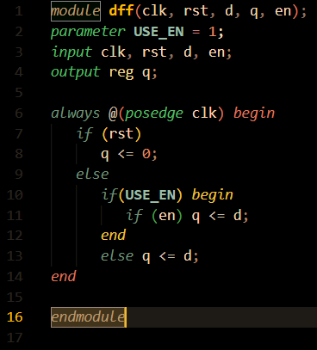
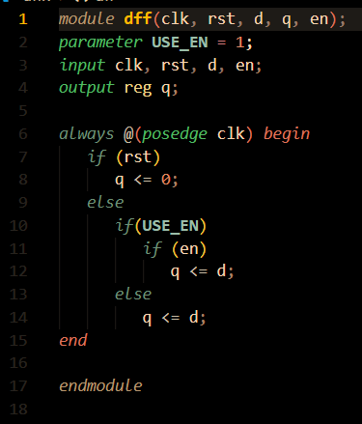
The DFF design has missing begin end that causes a bug in the results which is when enable signal is zero the output q signal still updates with the changes in the input d signal.

design after justifications
design before justifications

Testbench
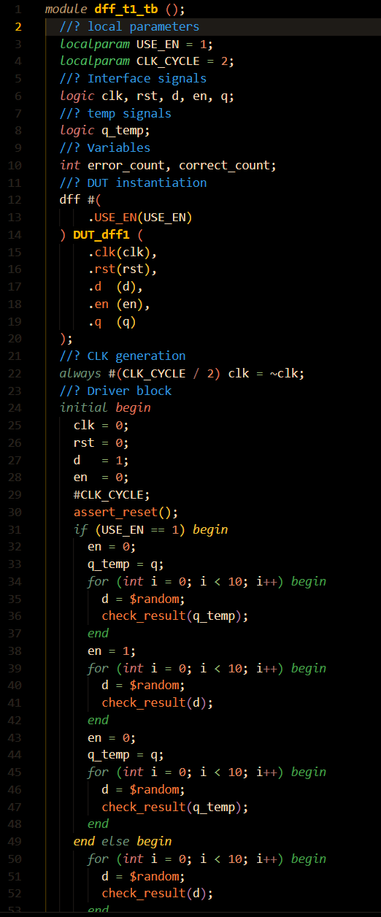
The two testbenches are the same except the USE_EN parameter value.

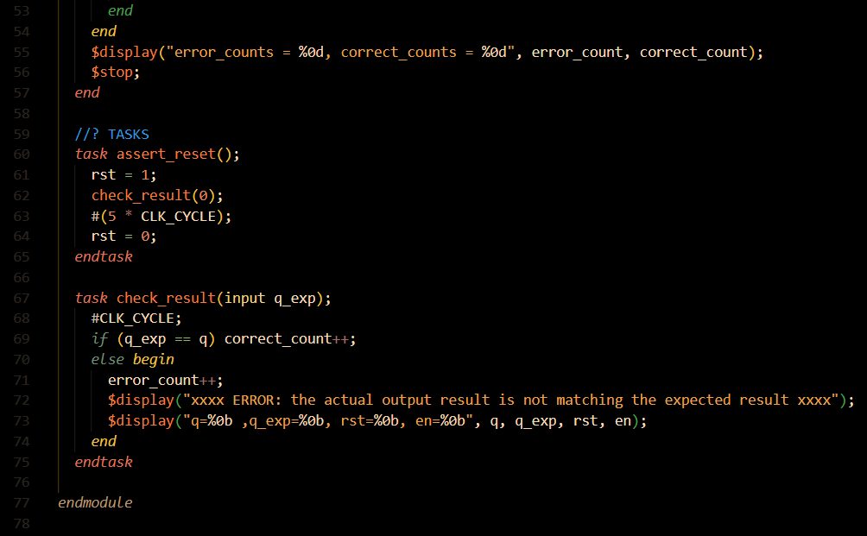

DO file
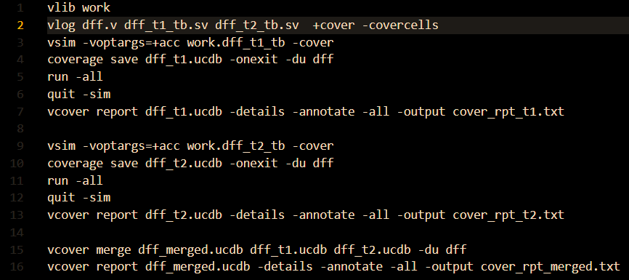

Coverage report

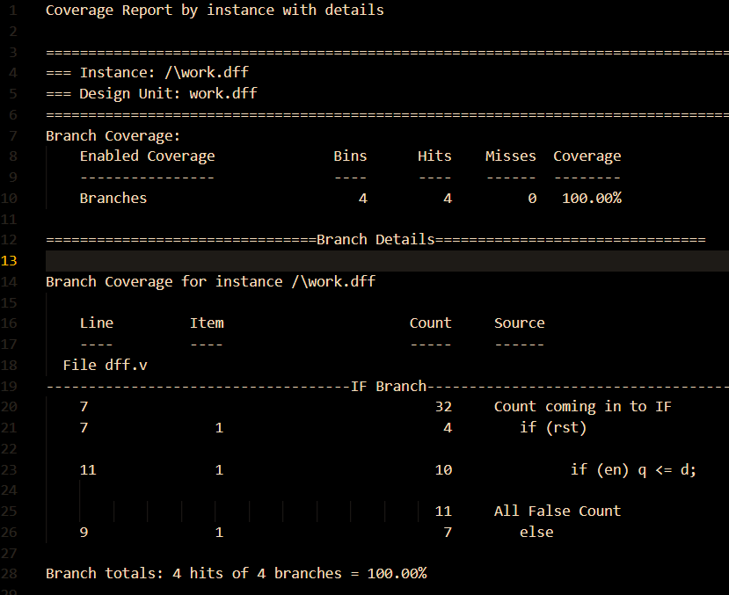
Branch coverage (merged)

Statement coverage (merged)
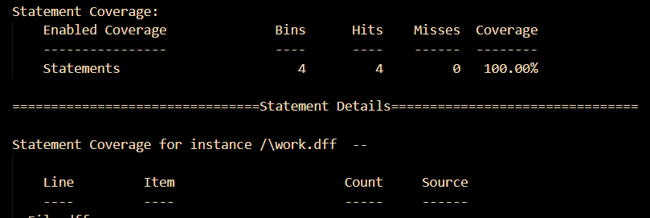

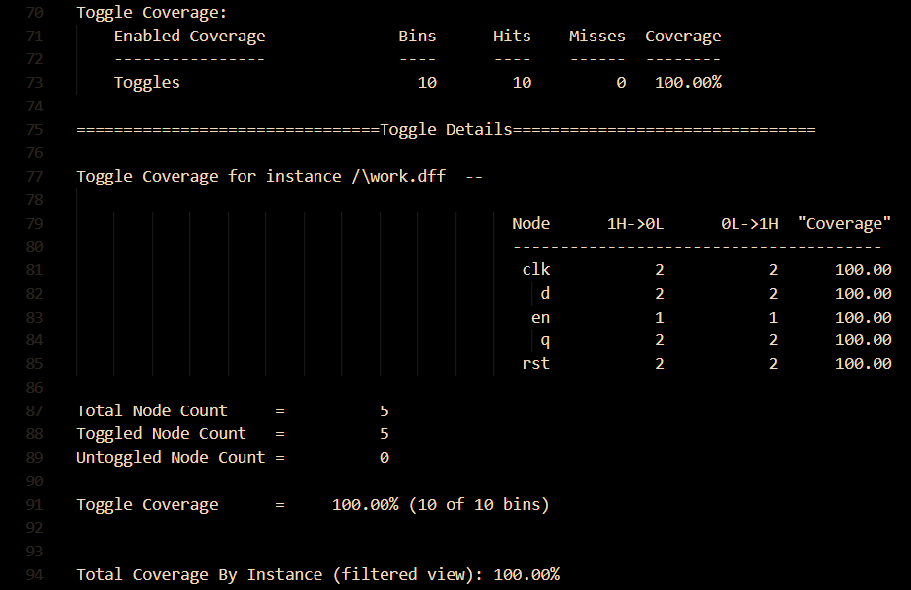
Toggle coverage (merged)

